BIRLA INSTITUTE OF TECHNOLOGY & SCIENCE, PILANI
Work Integrated Learning Programmes Division
Cluster Programme - M. Tech in AI & ML
II Semester , 2023 – 24(July,2024)
Mid semester Examination (Regular)_ANSWER KEY
Course No : AIMLC ZG511
Course Title : DEEP NEURAL NETWORK
Nature of Exam. : Closed Book
Number of questions:5
Number of Pages: 2
Weightage : 30 Marks
Duration : 120 minutes
Date : 21st July,2024_2 PM
Q. No | Question | Marks
Q.1. | (x1, x2) are input features and target classes are either +1 or -1 as shown in the figure. x2 is never negative. A fully connected multilayer perceptron network is used for classification with 100% accuracy. Step activation functions are used at all nodes, i.e., output=+1 if total input >= bias b at a node, else output = -1.  - What is the minimum number of hidden layers and minimum number of hidden nodes in each hidden layer required? (2M)  ANSWER: It is a non-convex decision region. So, 2 hidden layers are needed, 1st hidden layer with 4 hidden nodes and 2nd hidden layer with 2 hidden nodes.  - Obtain the equations of the decision boundaries.(2M)  - Specify all weights and bias values at all nodes. Weights can be only +/-5 or 0, and bias 0 or +ve multiples of 5 only. Draw the minimal network architecture with obtained weights and bias values. Organize the nodes in each layer horizontally and show the node representing x1 at the left on the input layer. Organize the hidden nodes in ascending order of bias at that node. Show all calculation steps. (4M)  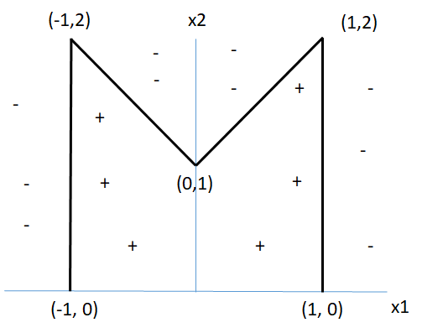  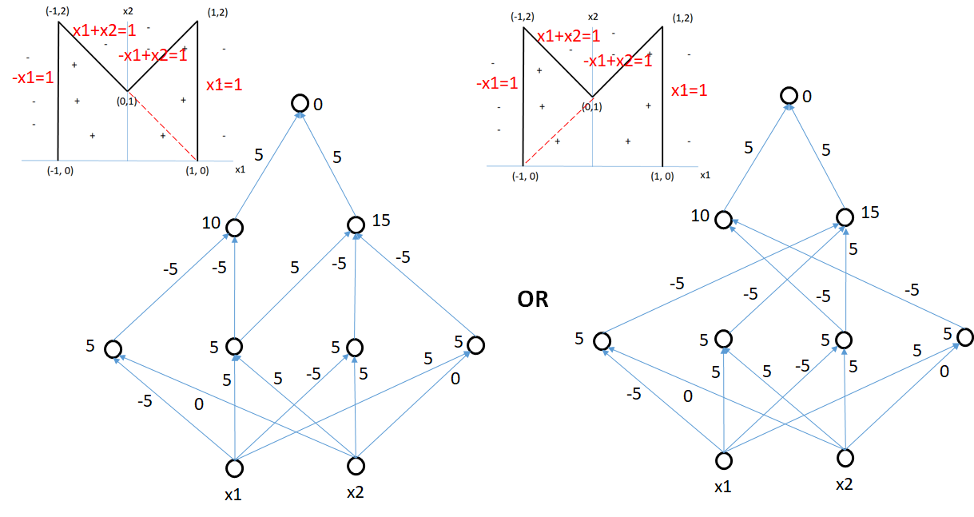 | 8M
Q.2 | Consider the binary classification problem given below:  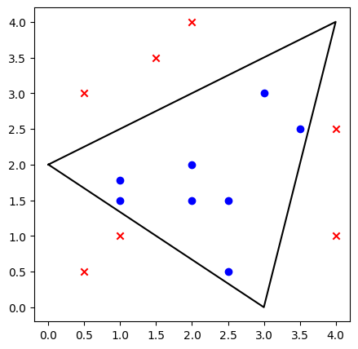  - How many perceptrons and how many layers are required to classify the above points with 100% accuracy. [1M]  ANSWER: 3 perceptrons to represent each one of the decision boundaries in one hidden layer.  - Sketch the MLP architecture with appropriate weights and biases to classify the above data points. [4M]  Equation of the 3 lines and hence the three inequalities:  Line between (3,0) and (0,2) : y = (-⅔)x + 2 or 2x + 3y - 6 = 0  Weights and bias for corresponding neuron: weights = [2,3] b = -6 [1 M]  Line between (3,0) and (4,4) : 4x - y - 12 =0  Perceptron condition: -4x+y+12 > 0  Weights and biases : (-4, 1) b = 12 [1 M]  Line connecting (0,2) and (4,4) -x+2y - 4 = 0  Weights and bias; [-1, 2], b = -4 [1 M]  Final Perceptron: AND of all 3 inputs  One possible combination is (1,1,1) and b = -3 [1 M] | 5M
Q.3 | a) Give two strengths and two weaknesses of neural networks in comparison to other machine learning models. [2M]  ANSWER:  Strengths (Any 2 points – 1 mark):  - Excellent at automatically learning complex features from raw data, reducing reliance on hand-crafted features (Feature extraction).  - Handles complex, non-linear relationships in data & modeling patterns (non-linearity).  - Handles high-dimensional data in image, text, and speech tasks.  - Adaptable for different types of Data and perform different types of tasks.  - Generalize from large data.  Weaknesses (Any 2 points – 1 mark):  - Need for Large Datasets.  - Requirement of High Computational Resources.  - Difficult to interpret the inner workings of a neural network, leading to a "black box" problem.  b) A neural network is trained and tested over a dataset for which training accuracy is 100% and the testing accuracy is 45%. What are the inferences from this and how to handle this? Discuss.[3M]  ANSWER:  Overfitting (1 Mark) can be inferred when a neural network achieves 100% training accuracy but only 45% testing accuracy. This phenomenon occurs because the model becomes exceptionally proficient at fitting the training data, yet it struggles to generalize effectively to unseen / testing data.  The following strategies can improve generalization of the network (any 2 strategies = 2 Marks):  - L1 & L2 regularization to penalize large weights. This helps prevent overfitting.  - Dropout helps combat overfitting by introducing noise.  - Early Stopping: Monitor validation loss during training and stop when it starts increasing (indicating overfitting).  - More Data: The dataset may be small, hence the model has easily overfit. Collect more diverse data to improve generalization.  - Simpler Model: Consider using a simpler architecture or reducing the model’s capacity. The neural network might be too complex, capturing noise or irrelevant features specific to the training data.  - Cross-Validation: Use techniques like k-fold cross-validation to assess performance more robustly.  Data Augmentation: Generate additional training examples by applying transformations (e.g., rotations, flips) to existing data | 5M
Q.4 | Consider the following simple CNN architecture:  Input: 64x64x3 (RGB image),  Convolutional Layer 1: [64 filters of size = 2x2, stride = 2, padding = ‘valid’],  Batch Normalization Layer: Applied after Conv Layer 1,  Pooling Layer 1: [Max pooling with filter size = 2x2, stride = 2, padding= ‘valid’],  Convolutional Layer 2: [32 filters of size = 3x3, stride = 1, padding = ‘valid’],  Pooling Layer 2: [Average pooling with filter size = 4x4, stride=2, padding= ‘valid’],  Flatten, Fully Connected Layer: [128 neurons],  Output Layer: [10 neurons (for classification)]  For each layer of the architecture, calculate the number of the feature maps / neurons, size of the feature maps, trainable parameters, and non-trainable parameters?  Layers Number and size of output feature maps / neurons Trainable Parameters Non-Trainable Parameters  Conv Layer 1 Number: 64 and Size: 32 x 32 Filter Weights: 3x2x2 * 64 = 768 Biases: 64 Total: 832 parameters None  Batch Normalization Layer Number: 64 and Size: 32 x 32 Gamma (Scaling): 64 parameters (one for each output channel) Beta (Shift): 64 parameters (one for each output channel) Total: 128 parameters Running Mean: 64 parameters (one for each output channel) Running Variance: 64 parameters (one for each output channel) Total: 128 parameters  Pooling Layer 1 (Max) Number: 64 and Size: 16 x 16 None None  Conv Layer 2 Number: 32 and Size: 14 x 14 Filter Weights: 64x3x3 * 32 = 18432 Biases: 32 Total: 18464 parameters None  Pooling Layer 2 (Average) Number: 32 And Size: 6 x 6 None None  Flatten Neurons = 6x6x32 = 1152  Fully Connected Layer 128 neurons Weights: 1152 * 128 = 147456 Biases: 128 Total = 147584 parameters None  Output Layer 10 neurons Weights: 128 * 10 = 1280 Biases: 10 biases Total: 1290 parameters None  All layers (Total) Total = 168298 parameters Total: 128 (from Batch Normalization layer) parameters. | 6M
Q.5. | We know that in CNN architecture consists of Convolution layers, pooling layers, Fully connected layer and output layer. Answer the following.  i).”In CNN, regularization can be applied to any of these layers except output layer in case of overfitting”. Validate the statement and justify.  ii) What are the activation functions to be used in output layer? When to use them? Discuss.  iii) Mention the hypermeters in a CNN which helps us to have the better architecture? | 6M
Solution:
i) Regularization in CNN Layers
Statement: "In CNN, regularization can be applied to any of these layers except the output layer in case of overfitting."
Validation and Justification:
Regularization is a technique used to prevent overfitting by adding a penalty to the loss function to discourage complex models. In Convolutional Neural Networks (CNNs), regularization can indeed be applied to various layers, but it is typically not applied to the output layer for the following reasons:
1. Convolution Layers: Regularization methods like Dropout, L2 regularization, and Batch Normalization are commonly applied to convolution layers to prevent overfitting by ensuring the model does not rely too heavily on any single feature.
2. Pooling Layers: Pooling layers themselves do not have parameters that can be regularized, but they contribute to regularization by reducing the spatial dimensions of the input, thereby controlling overfitting to some extent.
3. Fully Connected Layers: These layers are prone to overfitting due to a large number of parameters. Regularization techniques such as Dropout and L2 regularization are often applied here to reduce overfitting.
4. Output Layer: The output layer typically uses an activation function like softmax (for classification) or a linear activation (for regression). Regularization is generally not applied here because:
- The primary role of the output layer is to transform the network's output into the desired format (e.g., class probabilities).
- Regularization at this stage does not significantly impact the model's ability to generalize since it does not control the complexity of the learned features but merely transforms them.
Therefore, while regularization is crucial in convolutional and fully connected layers, it is not typically applied to the output layer.

ii) Activation Functions in the Output Layer
Activation Functions:
- Softmax:
- Usage: Multiclass classification problems.
- When to Use: When the task involves predicting one class out of multiple possible classes (mutually exclusive classes). Softmax converts the logits into probabilities that sum to 100%.
2. Sigmoid:
- Usage: Binary classification problems.
- When to Use: When the task involves predicting one of two possible classes. Sigmoid activation outputs a probability between 0 and 1.
3. Linear:
Usage: Regression problems.
When to Use: When predicting a continuous value. The linear activation function is used as it allows the output to take any real value.
4. Tanh:
- Usage: Sometimes used for regression tasks, though less common.
- When to Use: When the output is required to be between -1 and 1.
iii) Hyperparameters in CNN
Hyperparameters are crucial for tuning a CNN to achieve optimal performance. Some important hyperparameters include:
1. Learning Rate:
- Controls the step size during the optimization process.
- Too high can cause the model to converge too quickly to a suboptimal solution.
- Too low can result in a long training time or getting stuck in local minima.
2. Batch Size:
- Number of training samples used to compute the gradient during training.
- Smaller batch sizes can lead to noisy gradients but can help the model generalize better.
- Larger batch sizes provide smoother gradients but may require more memory.
3. Number of Epochs:
- Number of times the entire training dataset passes through the network.
- Too many epochs can lead to overfitting, while too few can result in underfitting.
4. Kernel Size:
- Size of the filter applied in the convolutional layers.
- Larger kernels capture more context but may lose finer details.
- Smaller kernels capture finer details but may miss broader context.
5. Number of Filters:
- Number of filters in each convolutional layer.
- More filters can capture more features but increase computational complexity and risk of overfitting.
6. Dropout Rate:
- Probability of dropping a neuron during training to prevent overfitting.
- Common values are between 0.2 and 0.5.
7. Weight Initialization:
- Method to initialize the weights of the network.
- Proper initialization can lead to faster convergence (e.g., He initialization for ReLU activations).
8. Optimizer:
- Algorithm used to minimize the loss function (e.g., SGD, Adam).
- Different optimizers have different properties and can affect the convergence speed and final performance.
9. Activation Functions:
- Functions applied after each layer to introduce non-linearity (e.g., ReLU, Leaky ReLU).
10. Regularization Parameters:
- Parameters like L2 regularization strength or dropout rate.
11. Pooling Size and Stride:
- Parameters that define the pooling operation, which reduces the spatial dimensions of the feature maps.
Choosing and tuning these hyperparameters effectively can significantly improve the performance and generalization of a CNN.

